# CS 401 Group Project

Software Requirements Specification  
for the Distributed File System (DFS)

Revision History

|  |  |  |  |
| --- | --- | --- | --- |
| **Date** | **Revision** | **Description** | **Author** |
| 02/12/2022 | 1.1 | Initial Version | Miles Vizinau, Moises, Isaiah |
| 02/16/2022 | 1.2 | Edited Text | Miles Vizinau, Isaiah |
| 02/18/2022 | 1.3 | Included Use Case Templates | Issiah |
| 02/19/2022 | 1.4 | Edited Text, Included some Reference Diagrams | All |
| 02/20/2022 | 1.5 | Included Sequence diagram | Miles |
| 02/26/2022 | 1.6 | Modified Class Diagram and Module Requirements | Miles |
| 02/28/2022 | 1.7 | Added notes from 02/28 client meet. Yes to supervisor, no to encryption, system should scale indefinitely. | Issiah |
| 03/18/2022 | 1.8 | Updated Module Requirements and Class Diagrams | Miles, Moises |
| 3/21/2022 | 1.9 | Updated User and Storage Module | All |
| 04/05/2022 | 2.0 | Updated to reflect design document | All |
|  |  |  |  |
|  |  |  |  |
|  |  |  |  |
|  |  |  |  |
|  |  |  |  |
|  |  |  |  |
|  |  |  |  |
|  |  |  |  |

Table of Contents

1. Purpose 4

1.1. Scope 4

1.2. Definitions, Acronyms, Abbreviations 4

1.3. References 4

1.4. Overview 4

2. Overall Description 5

2.1. Product Perspective 5

2.2. Product Architecture 5

2.3. Product Functionality/Features 5

2.4. Constraints 5

2.5. Assumptions and Dependencies 5

3. Specific Requirements 6

3.1. Functional Requirements 6

3.2. External Interface Requirements 6

3.3. Internal Interface Requirements 7

4. Non-Functional Requirements 8

4.1. Security and Privacy Requirements 8

4.2. Environmental Requirements 8

4.3. Performance Requirements 8

# Purpose

This document outlines the requirements for the Distributed File System (DFS).

## Scope

This document will catalog the user, system, and hardware requirements for the DFS. It will not, however, document how these requirements will be implemented.

## Definitions, Acronyms, Abbreviations

**Client:** An application that's installed the node that can be used to communicate with the server software

**Distributed File System (DFS)**: The main purpose of the Distributed File System (DFS) is to allows users of physically distributed systems to share their data and resources by using a Common File System

**Node**: The physical hardware that software can be downloaded on, like a computer

**Server**: A computer or computer program which manages access to a centralized resource or service in a network

**User**: The physical person operating the hardware

## References

Use Case Specification Document

UML Use Case Diagrams Document

Class Diagrams

Sequence Diagrams

## Overview

The Distributed File System (DFS) is designed to act as a private storage system for a single company. As information leaking is an ever-present danger this system will ensure that only individuals associated with the company can access the file system

# Overall Description

## Product Perspective

## Product Architecture

The system will be organized into 5 major modules: the User module, the Node module, the Client module, the Server module, and the File module

## Product Functionality/Features

The high-level features of the system are as follows (see section 3 of this document for more detailed requirements that address these features):

* + - All files are hidden on users’ nodes
    - Any file type should be supported
    - Client software allows the user to talk to the server software
    - Server software keeps track of where files are located
    - Verified users should be allowed to access the DFS

## Constraints

* + - Employees have to request files from the server
    - Only employees can access the system (EX: using employee id & password)
    - Server doesn’t store files

## Assumptions and Dependencies

* + - Only employees are using this software
    - All employees have a verified ID and password issued by the company
      * All supervisor IDs start with a “S”
    - The DFS software is installed only on a company computer

# Specific Requirements

## Functional Requirements

### Common Requirements:

* Users will request files from the server software using the client software

### User Module Requirements:

* + - Users should have a User ID and password
      * Supervisors will have “S” as the 1st character in their ID
      * Non-supervisors won’t have “S” as the 1st character in their ID
    - Users should have a way to tell if they’re currently using any client software
    - Users should only be able to have open 1 piece of client software at a time
    - Supervisors can: delete files from the entire system, remove users, and view an event history log

### File Module Requirements:

* + - Must contain file size, name, type, and path

### Client Module Requirements:

* + - Should provide an interface for user to log in and out
    - Should be able to open and close the server
      * Server should only close if there are 0 clients logged in
    - Should be able to send requests to server software for file operations

**3.1.5. Server Module Requirements:**

* + - Must have an event history
    - Must have a list of accessible files
      * Hidden and Unhidden files
    - Must have a list of client software currently accessing the server
    - Must be able to handle multiple clients at a time
    - Supervisor can close the server and end access to application for current users

**3.1.6. Node Module Requirements:**

* + - Must have a name
    - Must have a storage size
    - Only 1 user can be active on a node (computer) at a time
    - Contains a list of available users
    - Node possesses 2 storage classes
      * Hidden storage class
      * Unhidden storage class

**3.1.7 Hidden Storage Class:**

* + - Has a list of files that we do not want everyone to have access to
    - To access hidden files, must be supervisor

**3.1.8 Unhidden Storage Class:**

* + - Has a list of files that everyone has access to

## External Interface Requirements

* + - The user must have direct access with the client software in order to have the server manage the files
    - The client software must be able to recognize users and non-users (A login system)
    - The user should be provided an interface that allows them to log in to the DFS. If the user does not have an account, then they should have an option to create one.

## Internal Interface Requirements

* + - The system must process data from the user to a node (a computer); which contains the client software. The client software must send a request to the server file system and send the data back to the user
    - There exists an interface that encompasses both storage classes

# Non-Functional Requirements

## Security and Privacy Requirement

* + - Users with supervisor status should be given certain privileges
      * Access to event history of the DFS
      * Access to the complete file system
    - The system will NOT encrypt any data or files sent across the network.

## Environmental Requirements

* Every computer the company issues will have access to the same files using the DFS software
* The system will utilize the Java programming language.

## Performance Requirements

* System should be able to handle an indefinite number of clients and grow without constraint.

**Use Case Specification (Description) Template**

Use Case ID: *{0}*

Use Case Name: *{File Upload}*

Relevant Requirements: * *{3.1.1}*

Primary Actor: *{DFS Client}*

Pre-conditions: *{User must log in with valid ID and the file to upload must exist.}*

Post-conditions: *{If file does not already exist, file is uploaded to the DFS}*

Basic Flow or Main Scenario: *{Numbered flow of events: 1 The user logs in with ID, 2 The user requests to upload a file, 3 The user selects the file to upload, 4 The client uploads the file to the DFS*

Extensions or Alternate Flows: *{Alternatively, if the file already exists, prompt the user to choose whether they want to replace the identical file name or skip this action.}*

Exceptions: *{File no longer exists or cannot be found.}*

Related Use Cases: {File request}

**Use Case Specification (Description) Template**

Use Case ID: *{0}*

Use Case Name: *{File Request}*

Relevant Requirements: * *{3.1.1}*

Primary Actor: *{DFS Client}*

Pre-conditions: *{User must log in with valid ID.}*

Post-conditions: *{If the file requested exists, the client will request it from the server and it will be returned to the user.}*

Basic Flow or Main Scenario: *{Numbered flow of events: 1 The user logs in with their ID, 2 The user requests to retrieve a file, 3 The client checks with the server if the file exists, 4 If it does, file is returned to the user who requested it.}*

Extensions or Alternate Flows: *{Alternatively, if the file does not exist, then inform the user.}*

Exceptions: *{Error: file does not exist.}*

Related Use Cases: {File upload}

**Use Case Specification (Description) Template**

Use Case ID: *{1}*

Use Case Name: *{Supervisor privileges}*

Relevant Requirements: * *{4.1}*

Primary Actor: *{User/Supervisor}*

Pre-conditions: *{Supervisor must enter valid supervisor ID}*

Post-conditions: *{If ID is valid, the user will be granted access to the event history of the DFS as well as the entire file system.}*

Basic Flow or Main Scenario: *{Numbered flow of events: 1 The user logs in with their supervisor ID, 2 The user requests access to the event history or to the entire file system, 3 Access granted}*

Extensions or Alternate Flows: *{N/A}*

Exceptions: *{Invalid supervisor ID}*

Related Use Cases: {N/A}

**Use Case Specification Diagram(s)**

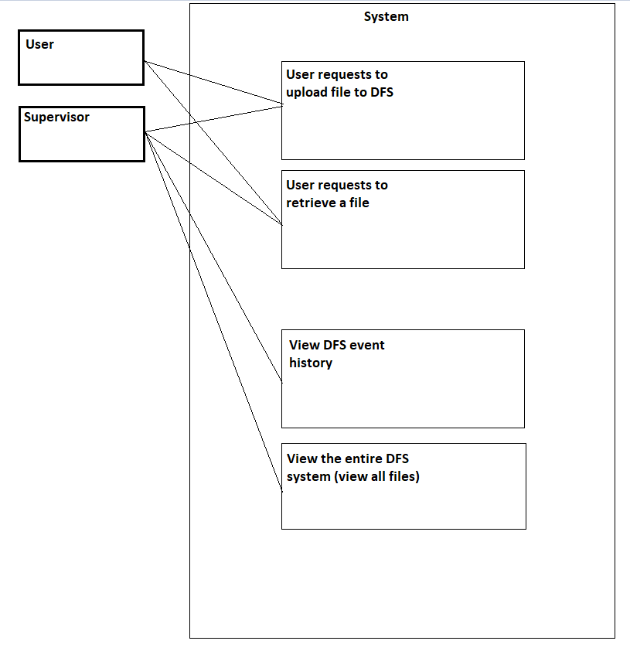

**Class Diagram(s)**

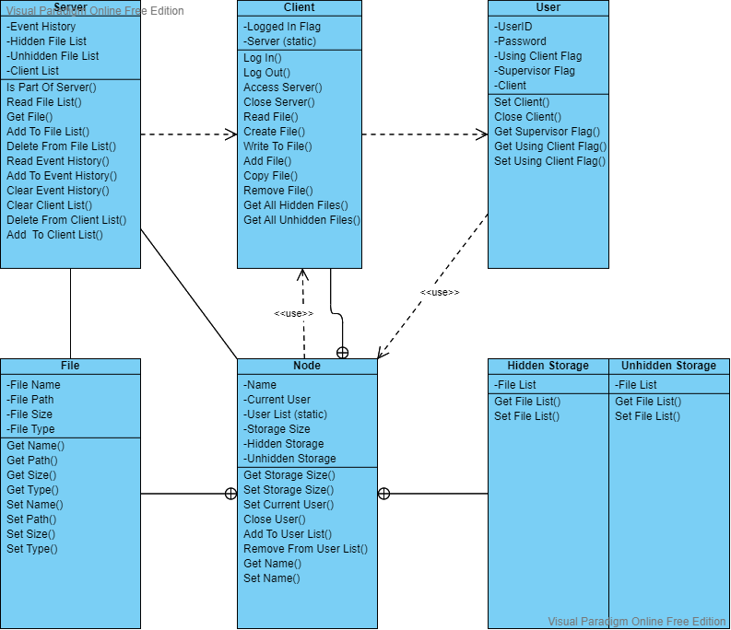

**Sequence Diagram(s)**

